
EXTENSION LECTURE WAS DELIVERED TO GOVT JUNIOR COLLEGE STUDENTS BY SRI V.CHITTIBABU, LECTURER IN COMMERCE, SGA GOVT DEGREE COLLEGE, YEALLAMANCHILI
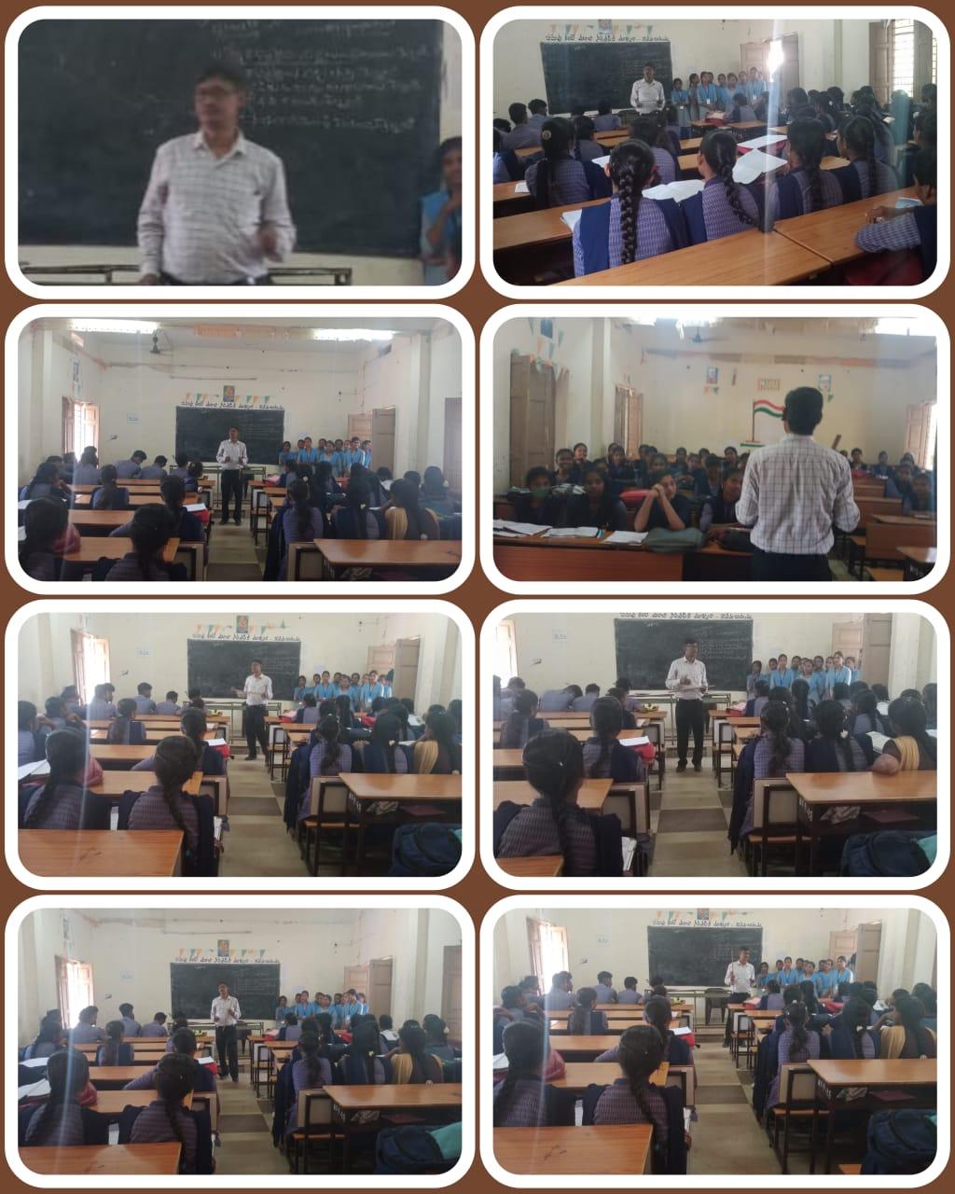

B.COM 3RD SEM STUDENTS, SGA GOVT DEGREE COLLEGE, YELLAMANCHILI, HAVE COMPLETED THE SYLLABUS OF C.E.C. GROUP IN THE GOVT JUNIOR COLLEG, YELLAMANCHILI 